

Dear Regional SAFECON Host:

Enclosed are 190 blank engraved award certificates. They are to be used for the winners of places 6-10 (if your regional only uses the 1-10 scoring method), or 6-20 (if your regional uses the 1-20 scoring method).

A CD-ROM with a word file formatted to print the certificates on LASER printers is included in the box. BE SURE TO PRINT PRACTICE CERTIFICATES ON PLAIN COPY PAPER BEFORE ATTEMPTING TO USE THE CERTIFICATES! You will need a maximum of 165 certificates if there are no ties. The extra 25 enclosed certificates are to cover any ties as well as any mistakes in printing. A second CD-ROM with the word file is also included inside this box.

You can scan a copy of the regional president’s and the chief judge’s signatures for use on the certificates. To help the appearance of the signatures, do not use fine or extra fine pens. Gel pens of at least .7mm work best. They produce a nice thick-lined signature. You can even use a sharpie type marker as long as the signature is written large enough to shrink down and still be legible.

Sincerely,

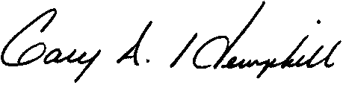
Gary A. Hemphill
NIFA Executive Director

